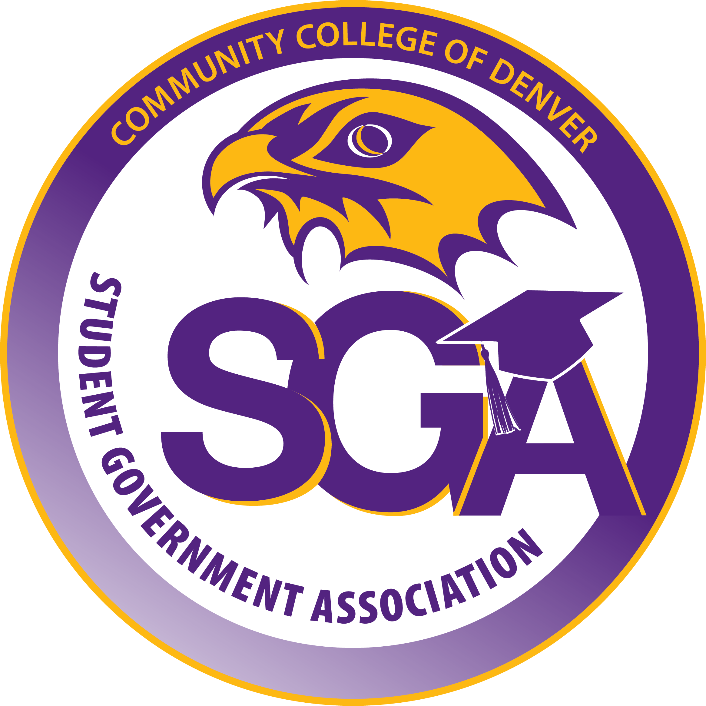
Community College of Denver
Student Government Association
Date: 10/22/25
Sponsored by: Joanna Sanchez
Authored by: April Ortiz
Aid Year 24-25 – Semester: Fall 2025
Approval of SGA: College 101 Event –Fall 2025
WHEREAS, the Student Government Association (SGA) is committed support student success through collaboration, and engagement, ensuring every student has the tools needed to thrive both academically and socially;
WHEREAS the SGA: College 101 Event on November 11th, 2025, aims to welcome, inform, and empower CCD students by connecting them with essential resources including academic support and opportunities through tabling and presentations;
WHEREAS this event will provide an inclusive and interactive environment that encourages students to build meaningful relationships with peers, faculty, and staff while gaining valuable insight into the diverse programs and services CCD offers;
BE IT RESOLVED THAT that the Student Government Association hereby approves the planning, promotion, and execution of the SGA: College 101 Event – Fall 2025;
THEREFORE, BE IT ENACTED by the Student Government Association of the Community College of Denver, AS FOLLOWS; that SGA shall allocate the appropriate funding, resources, and personnel to ensure the success of the event and collaborate with campus departments, and community partners to maximize participation.
Section 1: The SGA will allocate $600 for finger food, decorations, and goodie bags
Section 2: All unused funds approved in this bill will be returned to the Community College of Denver Student Government Association operating budget.
Section 3: This bill takes effect upon passage by the Student Government Association, and upon obtaining the signatures of the SGA President and SGA Advisor(s).
Vote Count:
President: April Ortiz

