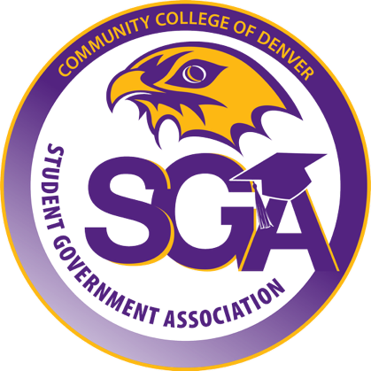
Community College of Denver
Student Government Association

Date: 10/17/25
Sponsored by: Monica Sanchez
Co-sponsor(s): April Ortiz
Authored by: Monica Sanchez
Aid Year (2025) – Semester - Fall
Approval of Remember Me (Day of The Dead Ofrenda) – Fall 2025

Bill History

WHEREAS, The Student Government Association (SGA) is committed to fostering and acknowledging history and culture to celebrate Community College of Denver students;

WHEREAS, Remember Me (Day of Dead Ofrenda) tabling event starting November 4th till November 21st, will give Community College of Denver students an opportunity to celebrate Hispanic traditions and create a sense of community;

WHEREAS, this event is aimed at building community, increasing student engagement, and ensuring the honor of the lives of students through the creation of the Ofrenda. Coming together as CCD student to celebrate life, remembrance, and cultural connection;

BE IT RESOLVED THAT, the Student Government Association will organize and host this event to strengthen the sense of community on campus, encourage collaboration among students, and foster an environment of inclusion, connection, and shared purpose.

THEREFORE BE IT ENACTED by the Student Government Association of the Community College of Denver, AS FOLLOWS;
Section 1: The SGA will allocate $200 for decorations for the tabling event.
Section 2: All unused funds approved in this bill will be returned to the Community College of Denver Student Government Association operating budget.
Section 3: This bill takes effect upon passage by the Student Government Association, and upon obtaining the signatures of the SGA President and SGA Advisor.

10/17/2025 Vote Count: 6/10,
President: April Ortiz SGA Advisors: Kloee Eisenbarth,

