Work-Study Student Handbook

Office of Financial Aid
FA.Workstudy@ccd.edu
financialaid@ccd.edu
303-556-5503

Table of Contents

Table of Contents 2
Student Employee Program Overview 3
Significant Dates & Deadlines 4
Eligibility 5
Award Limits 5
Job Postings 6
Hiring Process 6
Pay Rates/Worker’s Compensation 7
Work Schedule 8
Payroll Procedures 8
Employee Termination 9
Code of Ethics 10
Family Educational Rights & Privacy Act (FERPA) 11
Drug & Alcohol Policy 12
Appendix A 14

Work-Study Student Employee Program Overview
The Work-Study Student Employee program is federally and state funded. The program is designed to provide part-time employment for students with financial need. Students who participate have an opportunity to work on campus or at an authorized off-campus organization. In addition to students earning a portion of their educational costs, students gain valuable work experience.
CCD seeks to provide Student Employees the following:
- Opportunities for career development
- An environment to serve others
- Opportunities to demonstrate social responsibility
- A safe space for personal growth
- A “self-help” financial aid option

Significant Dates & Deadlines
Dates change from year to year. Students and supervisors should refer to the work-study website for updates as they become available. Work-Study Manager and HR will also rely important dates in a timely manner.

Eligibility
FAFSA or CASFA
Students must complete either the Free Application for Federal Student Aid (FAFSA), at studentaid.gov, or (CASFA) Colorado Application for State Financial Aid, at CASFA. The FAFSA or CASFA must be submitted each year and should be done as soon as it is available, TBD.
*Please Note: students should not fill out both applications, if you need help determining which application you should fill out, reach out to financialaid@ccd.edu.

Registered
Students must be enrolled in at least six (6) credit hours, which is defined as half-time status. If a student employee drops below six (6) hours, employment will be terminated immediately. Upon completion of each semester, only students enrolled for classes the following semester (fall or spring) are eligible to begin earning that semesters portion of their work-study award.

In order to be eligible for a summer award, students must be registered for at least six (6) credit hours for both the summer and fall semesters at CCD.

Good Standing
At all times, work-study student employees must be meeting Satisfactory Academic Progress (SAP). The requirements for SAP are overall GPA (minimum 2.0), overall completion rate (minimum 67%), semester completion of at least one attempted credit and overall attempted credit hour limits (must not exceed 150 percent of the student’s declared program length).

If the student employee does not maintain half-time status or meet SAP, they must stop working immediately. If they continue to work or record earnings, the department or organization will be billed 100 percent.

Award Limits
Academic Year

Work-study funds are offered to students that have completed the most recent FAFSA/CASFA available. For summer, students must complete current and upcoming applications, have submitted all requirements for their financial aid file and demonstrate financial need as determined by the FAFSA or CASFA.

Award
Students may be awarded up to a maximum work-study offer, up to cost of attendance, which will very from year to year for the upcoming fall/spring semesters. Students will receive two notifications of a work-study offer: general financial aid award letter and work-study award notice. The award notice should be brought to the student’s supervisor for current students or uploaded onto their application for students who are applying for new positions. The award overview can be used in lieu of the work-study award notice.

Work-study award amounts may vary from student to student based upon financial aid eligibility. Summer awards will be given to those students who satisfy the eligibility requirements, have completed their upcoming years FAFSA/CASFA, and are continuing CCD students.

A work-study award DOES NOT guarantee a work-study position.

Cancellation
Work-study funds are not guaranteed and may be reduced or cancelled at any time throughout the semester. Any part of the work-study award that is not earned at the end of each semester will be cancelled.

If the student earns more than their work-study award for the term or fiscal year, the department or organization will be billed 100 percent of the overpayment.

Job Posting
Available work study positions will be listed at https://www.ccd.edu/administration/non-academic-departments/financial-aid-scholarships/fa-what-it-how-do-i-apply/work-study. Interested hiring managers will contact applicants directly to schedule an interview.

Hiring Process
Eligibility/Award
The student must present a work-study award letter and class schedule to their potential supervisor. Once the supervisor has confirmed the student’s eligibility by gathering the work-study award notice or award overview and class schedule an interview can be scheduled.

Interview
The interview will be a professional and positive experience communicating the position duties, schedule, dress code and work ethic.

Background Check
All applicants are required to complete and pass a background check.

New Hire Paperwork
Once the supervisor receives the cleared background check, the student employee will complete new hire paperwork required by Human Resources online.

Work-Study Documents
All work-study documentation will be completed online via NeoEd. Students will need to complete the online onboarding process in a timely manner to avoid cancellation of the process.

Pay Rates/Worker’s Compensation
- Rate of pay is Denver County’s minimum wage. There is no differential in pay from continuing student employees and new hires.
- All Community College of Denver’s employees are automatically covered for injuries sustained in the course of employment. Employees must report all injuries to their supervisor as soon as possible and complete a “first report of injury” within 24 hours of the injury. Medical care for work-related injuries is provided at HEALTHONE or Concentra clinics/providers. The employee’s supervisor and/or CCD’s Benefits Specialist will provide the employee with the appropriate information. Employees may be financially responsible if they do not go to a designated worker’s compensation approved provider, excluding emergencies. All questions regarding worker’s compensation should be referred to Community College of Denver’s Benefits Specialist at 303-352-3004.

Work Schedule
The student employee supervisor must communicate to the student the required hours for the position, procedures when absent, and the flexibility of a schedule that will work around your classes.
- Students are not allowed to work during class time.
- Students are not allowed to work when the campus is closed.
Hours
Students may work up to 20 hours per week during the semester. There are NO EXCEPTIONS to this rule. Student employees may not work more than eight (8) hours in a day. *CCD has the right to adjust hours further as needed.
Breaks
Student employees working more than five (5) consecutive hours must take a 30-minute unpaid lunch break. It is the discretion of the supervisor if breaks other than lunch are permitted.

Overtime
Student employees are NEVER allowed to work over forty (40) hours a pay period. Student employees cannot receive overtime pay. If the student works more than twenty (20) hours in a week, the department or organization will be billed 100 percent.
Leaving a Position
If a student voluntarily leaves a position during the semester, the student is only eligible for rehire at another department or organization during the semester, if documented extenuating circumstances exist. This will be evaluated on a case by case basis.

Payroll Procedures
Students must complete a bi-weekly timesheet listing hours earned for each day worked through their CCD Connect account. The student employee supervisor will verify the hours earned and submit the approved timesheet through CCD Connect.
- Students should enter their hours daily.
- Students are paid for hours worked and not for anticipated hours.
- Students are not entitled to benefits like vacation or holiday pay in exchange for work.
- Students do earn one (1) hour of sick leave per every thirty (30) regular hours worked per pay period.
Submission & Approval of Timesheets
Student employees must submit timesheets through CCDConnect under the “Employee” tab and, when applicable, a department or organization timesheet prior to 12:00 a.m. (midnight) on the last day of the payroll period. Off-Campus student employees are required to submit their Off-Campus Timesheet and submit their electronic timesheet through CCDConnect by 3:00 p.m. on the day prior to the last day of the payroll period.
(see Appendix A for Time Reporting tutorial & Off-Campus Timesheet)

Employee Termination
An employer can terminate an employee at any time for any reason, except an illegal one, or for no reason without incurring legal liability. Likewise, an employee is free to leave a job at any time for any or no reason with no adverse legal consequences.
Reasons for Termination
There are two main actions for which a student employee may be terminated: unsatisfactory performance or behavior. Examples of these may include (but are not limited to) attendance issues, subpar performance, falsification of timesheet, abusing confidential information, theft, unauthorized or fraudulent use of equipment or property, or violation of CCD policies and procedures.
Process
The supervisor must provide notification to the student employee when performance or behavior is deemed unsatisfactory. They must also provide a reasonable timeframe for the student to correct the issue. Expectations presented by the supervisor must be clearly communicated and include any possible training opportunities.
If the student employee fails to meet the expectations of the corrective action plan, the department/organization has the ability to terminate the student employee. Once the student employee has been terminated, they will submit their timesheet through CCDConnect for the hours earned during the payroll period.

Code of Ethics
The State Board recognizes that employment within the Colorado Community College System should not bestow preferential benefit on anyone related to an employee by family, business, or social relationship. Immediate family is defined as spouse, children, stepchildren and their spouses, brothers and brothers-in-law, sisters and sisters-in-law, parents and parents-in-law, grandparents and grandparents-in-law, grandchildren and their spouses, and members of the immediate household. Disclosure of any possible preferential benefit circumstance must be made immediately to the president for evaluation and determination.
Faculty and staff of CCD will demonstrate the highest standards of personal integrity and will, through their conduct, inspire public confidence and trust. Confidential information acquired by virtue of employment with CCD will not be used for private gain.
State time, property, equipment, or supplies will not be used for personal or financial gain. Computers, telephones, fax machines and all other office equipment/supplies belong to the state and are not for personal use.
CCD employees will comply with the Electronics Communication policy, Board Policy 3-125. Employee emails are public record.
No employee will accept money or anything of monetary value where such acceptance may result in loss of independence and impartiality in the discharge of the employee in public duties.
Employees will not engage in outside employment that interferes with the performance of the duties of their position with CCD. Situations in which job performance appears to diminish will be reported immediately to the president for evaluation and determination.
Employees will not knowingly engage in any activity or business that creates a conflict of interest or adversely affects public confidence in the integrity of CCD.
CCD employees are stewards of the public trust. In their positions, they are under an affirmative obligation to carry out their duties with honesty, integrity and openness. When corruption exists, it will be reported immediately to the president.
Faculty and staff are prohibited from developing relationships with students that result in unfair gain or creating adverse circumstances for the student.
CCD has a zero tolerance policy on sexual harassment of students, faculty and staff. Any verbal or written allegations must be immediately reported to the Executive Director of Human Resources.
Supervisors have an affirmative obligation to submit any allegations of sexual harassment immediately.
CCD does not discriminate on the basis of race, color, creed, national origin, sex, sexual orientation, age or disability in admission or access to, or treatment or employment in, its educational programs or activities.

Family Educational Rights & Privacy Act (FERPA)
The Family Educational Rights and Privacy Act (FERPA) (20 U.S.C. § 1232g; 34 CFR Part 99) is a federal law that protects the privacy of student education records. The law applies to all schools that receive funds under an applicable program of the U.S. Department of Education.
FERPA gives parents certain rights with respect to their children's education records. Students to whom the rights have transferred are "eligible students."
Parents or eligible students have the right to inspect and review the student's education records maintained by the school
Parents or eligible students have the right to request that a school correct records which they believe to be inaccurate or misleading
Generally, schools must have written permission from the parent or eligible student in order to release any information from a student's education record. However, FERPA allows schools to disclose those records, without consent, to the following parties or under the following conditions (34 CFR § 99.31):
School officials with legitimate educational interest, other schools to which a student is transferring, specified officials for audit or evaluation purposes, appropriate parties in connection with financial aid to a student, organizations conducting certain studies for or on behalf of the school, accrediting organizations, to comply with a judicial order or lawfully issued subpoena, appropriate officials in cases of health and safety emergencies and state and local authorities, within a juvenile justice system, pursuant to specific state law.
Schools may disclose, without consent, "directory" information such as a student's name, address, telephone number, date and place of birth, honors and awards, and dates of attendance. However, schools must tell parents and eligible students about directory information and allow parents and eligible students a reasonable amount of time to request that the school not disclose directory information about them. Schools must notify parents and eligible students annually of their rights under FERPA. The actual means of notification (special letter, inclusion in a bulletin, student handbook or newspaper article) is left to the discretion of each school.

Drug & Alcohol Policy

COMMUNITY COLLEGE OF DENVER POLICY PROHIBITING THE UNLAWFUL POSSESSION, USE OR DISTRIBUTION OF ILLICIT DRUGS AND ALCOHOL BY EMPLOYEES

- STANDARDS OF CONDUCT: The Community College of Denver hereby prohibits the unlawful possession, use or distribution of illicit drugs and alcohol by employees on the property or as part of the activities of the college.

- DISCIPLINARY SANCTIONS: Employees who violate the foregoing standards of conduct shall be subject to disciplinary sanctions which may include, without limitation, completion of an appropriate rehabilitation program, reprimand, probation, correction action, demotion, reassignment with or without salary adjustment, suspension with or without pay, and termination. Disciplinary sanctions shall be consistent with local, state and federal law and shall be administered in accordance with state personnel system rules and procedures and policies or State Board or Community College of Denver policies. In addition to the foregoing disciplinary sanction, violations may be reported to law enforcement authorities for criminal prosecution.

- DEFINITIONS:
- “Illicit drugs” shall mean controlled substances listed in Schedules I-V of the Controlled Substances Act, 21 U.S.C. 812, and related federal regulations, 21 C.F.R. 1308.11 – 1308.15 as they may be amended from time to time and Schedules I-V of title 12, article 22, part 3 of the Colorado Revised Statues as it may be amended from time to time. “Illicit drugs” shall include controlled substance analogs as defined by federal and state law.

- “Alcohol” shall mean any beverage containing not less than 0.5% ethyl alcohol by weight.

- “Property” shall mean any property owned leased, chartered or occupied by the College including motor vehicles, boats and aircraft.

- Activities” shall mean any act or event sponsored or participated in by the College including their constituent administrative units and approved student organizations. Without limitation, “activities” shall include all athletic events, faculty, staff and students meetings, conferences, field trips, retreats and all other acts or events for which the College pays expenses, or provides facilities, services, supplies or transportation. “Activities” shall not include incidental work-or study-related activities which employees perform in their personal, off-campus residences or purely social events which are held off-campus and are organized or attended by employees solely in their personal capacities.

- IMPLEMENTATION: The College shall implement drug and alcohol abuse prevention programs which, at a minimum, meet the requirements of the Drug-Free Schools and Communities Act of 1989, 20 U.S.C.

- This policy is supplemental to and does not supersede or repeal other related State Board or College policies including the Colorado Drug-Free Workplace Policy.

- Health Risks Associated with Use of Illicit Drugs and Alcohol Abuse. Health risks associated with drug and alcohol abuse include, but are not limited to: malnutrition, brain damage, heart disease, pancreatitis, cirrhosis of the liver, mental illness, death, low birth weight babies, and babies with drug addictions.

The unlawful manufacture, distribution, dispensation, possession or use of a controlled substance in the workplace or state-owned vehicle by employees of the Community College of Denver is prohibited. As a term of her or his employment every employee shall:

1. Abide by the terms of this Policy Statement; and
2. Notify the appropriate personnel officer of any criminal drug statue conviction for a violation occurring in the workplace or a state-owned vehicle no later than 5 days after such conviction.

Any employee who violates the provisions of the Policy Statement shall be subjected to appropriate disciplinary action which may include termination.

Appendix A
TIME REPORTING – Hourly employees/Work-study/Student Hourly
If you are required to submit a timesheet, you need to log into the CCD Connect portal. If you are on campus, simply click the Internet Explorer button from a CCD computer to access the CCD Connect portal. If you are working off-site, go to www.ccd.edu and click the CCD Connect logo.
Your User Name is your S number (be sure to capitalize the S) and your password is your portal password. If you need assistance with your portal password, please contact the CCD IT Help Desk at 303-556-4283.

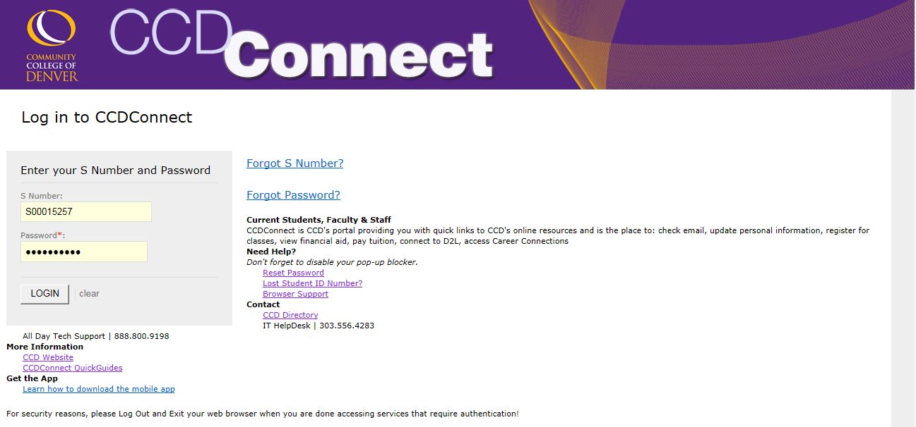
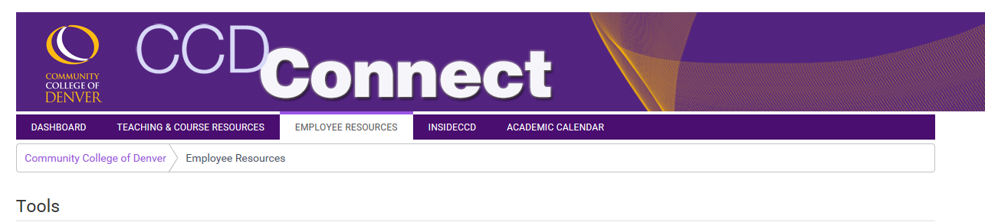
Once you log into the portal, make sure the Employee tab is open and look for the Time Reporting channel.
Choose which pay period’s timesheet you are completing. When you click the link for that pay period, your timesheet for that pay period will appear:
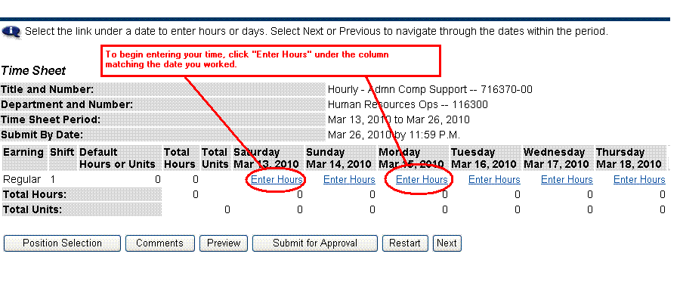

Please note the following
- Timesheets only display one week at a time. Click the Next button to see the second week of the pay period. (Likewise, if you are viewing the 2nd week of the pay period, click Previous to return to the first week of the pay period.)
- Time must be entered in 15 minute increments.
- If you work past midnight, the time must be entered on the new date. For example, if you work 4:00p-12:30a on March 1, you need to enter the hours from 4-12 on March 1, and from 12-12:30 on March 2.

To enter your hours, click Enter Hours under the column matching the date you worked. The following screen will appear when you click Enter Hours:
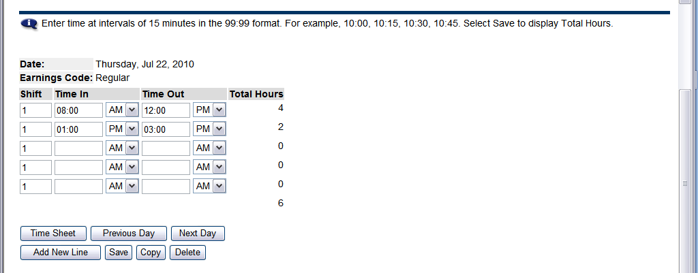
When you are finished entering your time, click the Save button.
AM or PM must be selected.
Time must be entered in 15-minute intervals.
Make sure you enter the time out for meals.
To return to your full timesheet, click the “Timesheet” button. If you’d like to go to the next date, click the “Next Day” button.

To enter your hours:
- Enter the Time In to the nearest quarter hour (15 minutes) under the Time In column. Use the AM selector to choose AM or PM.
- Enter the Time Out to the nearest quarter hour (15 minutes) under the Time Out column. Use the AM selector to choose AM or PM.
- Non-paid work time, such as a meal period, should be reflected in the hours worked. For example a typical work day may be as follows:
Time In Time Out
8:15 AM 12:00 PM
1:00 PM 5:15 PM
In this example, it is assumed that the employee took a meal period between 12:00 PM and 1:00 PM and therefore was “off the clock” during that time.
- If your hours go past midnight, remember that the time past midnight must be entered on the following date.
When you have finished entering time for this date, click Save. The Total Hours column will automatically calculate the total number of hours worked for that day.
To return to the timesheet, click Timesheet below the time entry area.
Before you finalize your timesheet, check to make sure that you have entered the correct number of hours for each day worked in the pay period; double-check the Total Hours calculation at the bottom of the time entry portion of the Timesheet.
When you have entered all your time and verified that everything is correct, click Submit for Approval.
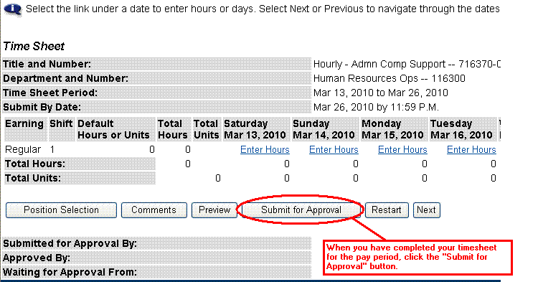
To certify and sign your timesheet electronically, you will need to enter your Self Service Banner (SSB) password. This is not necessarily the same as your portal password. If you don’t know your SSB password, please contact the CCD-IT Help Desk at 303-556-4283 for assistance.
Certify your timesheet by typing in your Self Service Banner password and click Submit
Once you have submitted a timesheet for approval, you cannot make any changes to the timesheet UNLESS:
- You click the Return Time button to pull the timesheet back. Please note that this feature can only be used IF the Timesheet Approver has NOT yet started the review for approval.
- Your Timesheet Approver returns your timesheet for correction.
If your timesheet is returned for correction, your supervisor will send you an e-mail notifying you that you must go in and make changes. If this happens, you must make the corrections and re-submit for approval before the designated due date.

How do I print my timesheet?
To print your timesheet, click the Preview button. Change your printer setting to Landscape before printing.

What if I notice a mistake after I’ve submitted my timesheet for approval?
If you realize that you made a mistake on your timesheet after you have submitted it for approval, you can pull the timesheet back and make the needed changes AS LONG AS the Timesheet Approver has NOT yet started the review for approval yet. To do this:
- Click the Return Time button.
- Make the needed change(s) on your timesheet.
- Click Submit for Approval. You will be required to certify your timesheet again by entering your Self Service Banner password.
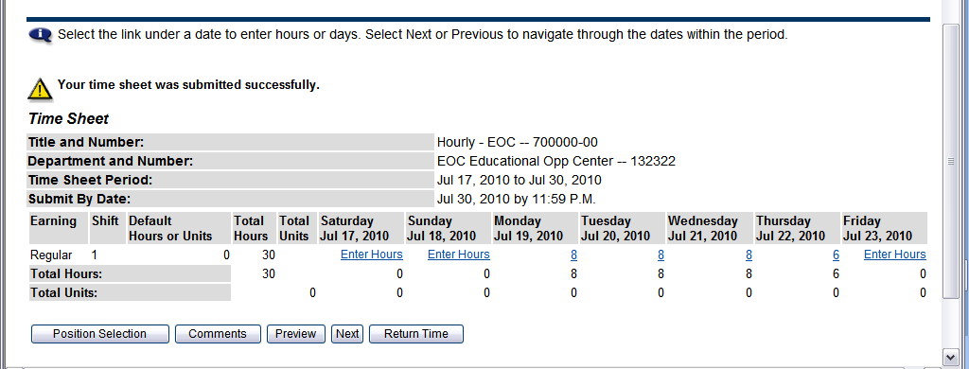

What if I messed up my timesheet or made numerous mistakes?
You can make changes to the Time In-Out for each individual day on the timesheet before it is submitted for approval (or after it is returned for correction).
You also have the option to restart your timesheet by clicking the Restart button. The Restart button deletes ALL entries you have made to your timesheet and will require you to start over.
Clicking Restart will give you a warning message that says, “Restarting will delete all changes that you have made to your time record. Select Submit to restart.”
Clicking Submit will wipe the entire timesheet clean so you can start all over. Please note that this option is NOT reversible! Please use extreme caution with the Restart button (if you use it at all). Click Cancel to return to the timesheet without restarting.
What if I Need Help?
The CCD IT Help Desk can assist you with portal and/or Self Service Banner passwords. Please call 303-352-3030 to reach the CCD Help Desk.
The CCD Human Resources staff can assist you with questions regarding timesheets.
Main Contact: Delma Valdez – 303-352-3008

