2021/2022
Work-Study
Supervisor Guide

Table of Contents

Table of Contents 2
Work-Study Program Overview 3
Significant Dates & Deadlines 4
Eligibility 5
Award Limits 5
Hiring Process 6
Off-Campus Employer/Supervisor 9
Pay Rates/Worker’s Compensation 11
Work Schedule 11
Payroll Procedures 12
Employee Termination 13
Employee Separation Information Form 14
Code of Ethics 14
Family Educational Rights & Privacy Act (FERPA) 15
Drug & Alcohol Policy 17
Appendix A 19

Work-Study Program Overview
The Community College of Denver work-study program is federally and state funded. The program is designed to provide part-time employment for students with financial need. Students who participate have an opportunity to work on campus or at an authorized off-campus organization. In addition to earning a portion of their educational costs, students will gain valuable work experience.
CCD seeks to provide Student Employees the following:
- Opportunities for career development
- An environment to serve others
- Opportunities to demonstrate social responsibility
- A safe space for personal growth
- “Self-help” financial aid with less long-term debt

Significant Dates & Deadlines
Dates are subject to change (supervisors will be notified through email)
Fall 2021
08/13/21 - Last day to earn summer WS award
08/16/21 – First day to earn fall WS award
08/23/21 – First day of fall classes
09/09/21 – Census date
10/01/21 – First day to complete 2022-23 FAFSA
12/13/21 – Last day of fall classes
12/24/21– Last day to earn fall WS award (CCD is closed 12/25/21 – 01/02/22, student employees are not eligible to work during this time)
Spring 2022
01/03/22 – First day to earn spring WS award
01/18/22 – First day of spring classes
05/06/22 – Last day to earn spring WS award
05/09/22 – Last day of spring classes

Eligibility
FAFSA
Students must complete the Free Application for Federal Student Aid (FAFSA) for the award year (AW) 2021-2022, at https://studentaid.gov/h/apply-for-aid/fafsa. The FAFSA must be submitted each year and can be completed as early as October 1.

Registered
Students must be enrolled in at least six credit hours, which is defined as half-time status. If a student employee drops below six hours, employment will be terminated immediately. Upon completion of the Fall 2021 semester, only students enrolled in spring classes are eligible to begin earning the Spring 2022 portion of their work-study award if you have submitted a spring job information for (JIF).

Summer
In order to be eligible for the summer 2022 award, students must be registered for at least six credit hours for both the summer and fall 2022 semesters at CCD. Students must also have a 2022-2023 work-study award. Summer 2022 awards will be given to those continuing student employees who satisfy the eligibility requirements, and have completed their 2022-2023 FAFSA.

Good Standing
Students must be meeting Satisfactory Academic Progress (SAP) at all times. The requirements for SAP are GPA (minimum 2.0), completion rate (minimum 67%), semester completion (at least one attempted credit) and overall attempted credit hour limits (must not exceed 150 percent of program length).

If the student employee does not maintain half-time status or meet SAP, they must stop working immediately. If they continue to work or report earnings, the department or organization will be billed 100 percent.

Important Note
Students that have earned a Bachelor’s Degree are not eligible for work-study at the Community College of Denver.

Award Limits
Academic Year
Work-study funds are offered to students that have completed their 2021-2022 FAFSA, submitted all requirements for financial aid and demonstrate financial need as determined by the FAFSA. The awarded funds are split between fall and spring.

Award
Students may be awarded up to a maximum work-study offer of $10,600 for the year. Students will receive two notifications of a work-study offer: general financial aid award letter and work-study award notice. The award notice should be brought to the student’s supervisor. If the student no longer possess their award notice, the award overview can be provided in its place.

The ORG owner of the department will communicate the allotted amounts for each student employee to the supervisor. The award offer may vary from student to student based upon financial aid eligibility.

Summer 2022 awards will be given to those continuing student employees who satisfy the eligibility requirements, completed their 2021-2022 and 2022-2023 FAFSAs.

Cancellation
Work-study funds are not guaranteed and may be reduced or cancelled at any time throughout the semester. Any part of the work-study award that is not earned at the end of each semester will be cancelled.

If the student earns more than their work-study award for the term or fiscal year, the department or organization will be billed 100 percent of the overpayment.

Hiring Process
Job Posting
Departments and organizations with available student employee job openings will post their positions through the work-study manager and will be available to view within the work-study program web page, www.CCD.edu/work-study. Supervisors will complete the job posting template and send over to the work-study manager for activation of the job posting (see job posting template under Appendix A).

Eligibility/Award
The supervisor must confirm the student’s eligibility and work-study award offer before scheduling an interview. The student should present a work-study award notice and a class schedule.

Interview
The interview should provide a professional and positive experience for the potential student employee. In the interview, the position duties, schedule, dress code and work ethic should be communicated to the potential student employee.

Background Check
(First step in the hiring process):
All applicants are required to complete and pass a background check. All new hire information must be processed through the new HR onboarding system called NeoEd. Contact HR to start the process. All new hire paperwork such as I-9, W-4, TIAA-CREF, etc will be handled in the HR department.

A new background check is required when a student has been terminated in Banner and not been paid for 120 days.

New Hire Paperwork
All new hire paperwork will be completed via NeoEd.

The student should submit following documents to complete new hire paperwork via email or in person:
- Government issued ID
- Social security card for payroll purposes
- Voided check or printout from bank with account number and routing number
- Permanent resident alien card (on I-9 indicated “lawful permanent resident” or “an alien authorized to work”), if applicable
- I-94 or I-20 (on I-9 indicated “an alien authorized to work”), if applicable
- TIAA-CREF enrollment confirmation page
Incomplete documents will delay the student from starting their position
- A student is not allowed to start their position until HR sends an email to the supervisor confirming the work-study job information form has been processed and the student employee is set up in Banner and has a timesheet
- Continuing student employees are eligible for employment once the Work-Study Manager sends the Work-Study Job Information form to HR

Off-Campus Employer/Supervisor

Off-Campus Employer Information Form
In order to determine that an off-campus employer site is an eligible work site for CCD student employees, the Employer Information Form must be completed and a job description must be attached. Once the site is approved, an email will be sent to the supervisor explaining the next steps.

Off-Campus Employer Agreement
Upon site approval, CCD will email the organization an Employer Agreement that will discuss the terms between CCD and the employer. The agreement is renewed annually and dated July 1st – June 30th of the next award year.
Job Posting
Organizations with available student employee job openings will post their positions through the work-study manager and will be available to view within the work-study program web page, www.CCD.edu/work-study. Supervisors will complete the job posting template and send over to the work-study manager for review prior to posting (see job posting template under Appendix A).

Hiring Process
The Organization MUST NOTIFY the Work-Study Manager at CCD of any potential student employee applicants that they wish to hire after the initial interview. The Work-Study Manager will confirm the student’s eligibility. The student is unable to start their position at the Organization until an email is received from Human Resources or the Work-Study Manager stating the student is set up for employment.

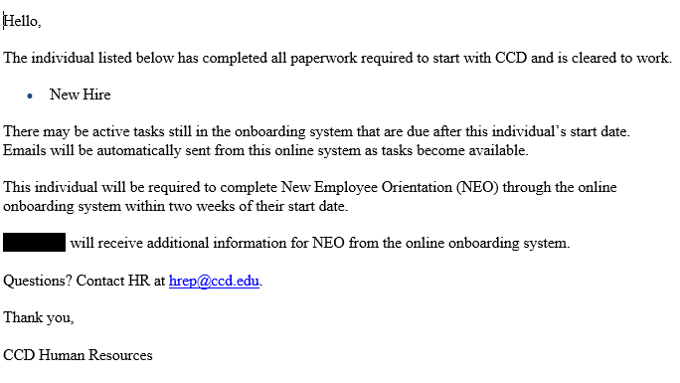
Timesheets
Students are required to record their time in and time out on a daily basis on the Off-Campus Timesheet and in CCDConnect. The supervisor must sign off on the time recorded for each student on the Off-Campus Timesheet. There must be a designated back-up representative to approve time when the supervisor is absent. Time worked must be recorded in 15 minute increments, rounding to the nearest quarter.
Time should only be entered under shift one. Shift two is never to be used by student employees.
Submission & Approval of Timesheets
Supervisors must email the Off-Campus Timesheet to the Work-Study Manager by 3:00 p.m. the day prior to the last day of the payroll period. The student must submit their timesheet bi-weekly, before midnight on the last day of the payroll period. The manager will compare the Off-Campus Timesheet to the electronic timesheet submitted by the student employee. If both match, the manager will submit the electronic timesheet for payment. If both do not match, the timesheet submitted by the student employee in CCDConnect will be returned to the student for correction and an email will be sent to the supervisor. Timesheets that have not been approved by 10:00 a.m. the Monday after the payroll period ends may be delayed ad the organization may be billed 100 percent of the student’s earnings.
Off-Campus Timesheet
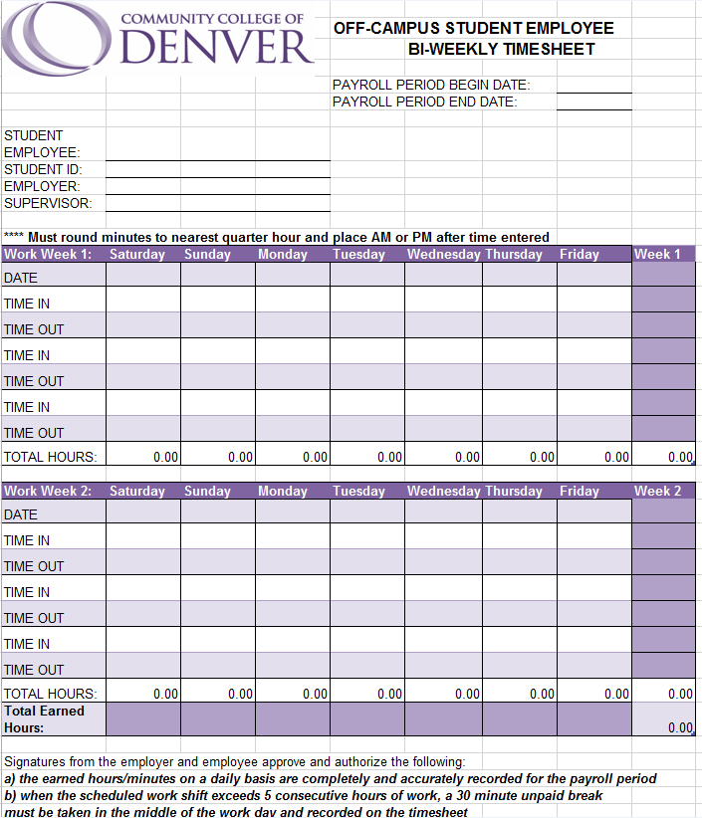

Pay Rates/Worker’s Compensation
- As of January, 2021, all student employees will be paid $14.77/hour. On January 1, 2022 the pay rate will increase to $15.87.
- All Community College of Denver’s employees are automatically covered for injuries sustained in the course of employment. Employees must report all injuries to their supervisor as soon as possible and complete a “first report of injury” within 24 hours of the injury. Medical care for work-related injuries is provided at HEALTHONE or Concentra clinics/providers. The employee’s supervisor and/or CCD’s Benefits Specialist will provide the employee with the appropriate information. Employees may be financially responsible if they do not go to a designated worker’s compensation approved provider, excluding emergencies. All questions regarding worker’s compensation should be referred to Community College of Denver’s Benefits Specialist at 303-352-3004.
  - This is why accuracy in time reporting is essential. If a work related injury occurs, an accurate timesheet is vital documentation.

Work Schedule
The student employee supervisor must communicate to the student the required hours for the position, procedures when absent and the flexibility of a schedule that will work around the student’s classes.
- Students are not allowed to work during class time.
- Students are not allowed to work more than 20 hours a week.
- Students are not allowed to work more than 8 hours a day.

Hours
Students may work up to 20 hours per week during the semester, including fall and spring break. Student employees may not work more than 8 hours in a day.
Breaks
Students working more than five consecutive hours gives the student a 30 minute unpaid lunch break. It is at the discretion of the supervisor if breaks are permitted other than the lunch break.
Overtime
Students are never allowed to be paid overtime or to work over 20 hours a week. If the student works more than 20 hours in a week, the department or organization will be billed 100 percent.
- If the student employee works more than 20 hours per week, the department or organization will be billed 100 percent over the 20 hours.
Sick Leave
Work-study students are considered employees as it related to SB 20-205, for sick leave. Sick leave can be used for a variety of safety or health needs including:
- A personal or family member’s mental or physical illness, injury, or health condition that prevents work, including diagnosis or preventive care;
- A personal or family member’s domestic abuse, sexual assault, or criminal harassment leading to health, relocation, legal, or other needs;
- During a public health emergency (such as the COVID-19 pandemic) when a public official closes the workplace, or the school or place of care of the employee’s child.
Student employees will accrue one hour of sick leave for every 30 hours worked up to a max of 48 hours. For example, an employee who worked 40 hours in a bi-weekly period will earn 1.33 hours of sick leave. Timesheets approval will continue as usual.

Payroll Procedures
Students must complete a bi-weekly timesheet through their CCDConnect account, listing hours earned for each day worked. The student employee supervisor will verify the hours earned and submit the approved timesheet through CCDConnect.
Off campus supervisors will verify hours earned via a paper timesheet.
- Students are paid for hours worked and not for anticipated hours.
- Students are not entitled to benefits like vacation or paid holidays in exchange for work.
Recording of Time In & Time Out
Students are required to record their time in and time out on a daily basis. The supervisor must sign off on the time recorded for each student. There must be a designated back-up representative to approve time when the supervisor is absent. Time worked must be recorded in 15 minute increments, rounding to the nearest quarter hour. An On-Campus Timesheet will be provided to utilize in the office.
Submission & Approval of Timesheets
The student must submit their timesheet by the last day of the payroll period before midnight. The supervisor has until 10:00 a.m. the Monday after the payroll end date to submit approved timesheets.
Retention of Records
Federal and state programs require departments and organizations to retain documents for three years (five years is recommended at CCD).

Employee Termination
An employer can terminate an employee at any time for any reason, except an illegal one, or for no reason without incurring legal liability. Likewise, an employee is free to leave a job at any time for any or no reason with no adverse legal consequences. The only exception to this is switching departments. An employee can only change departments at the end of a semester unless an extenuating circumstance exist.
Reasons for Termination
There are two main actions for which a student employee may be terminated: unsatisfactory performance or behavior. Examples of these may include (but are not limited to): attendance issues, subpar performance, falsification of timesheet, abusing confidential information, theft, unauthorized or fraudulent use of equipment or property or violation of CCD policies and procedures.
Process
The supervisor must provide notification to the student employee when performance or behavior is deemed unsatisfactory. They must also provide a reasonable timeframe for the student to correct the issue. Expectations presented by the supervisor must be clearly communicated and include any possible training opportunities. The supervisor should document all contact with the student regarding the situation and may use the Student Employee Disciplinary Action Form. Incidents occurring after one verbal and one written warning may be grounds for termination. (Student Employee Disciplinary Action form is located under the “G” drive > CCD Common > Work-Study Supervisor > Student Employee Disciplinary Action Form.)
If student fails to meet the expectations of the corrective action plan, the department/organization has the ability to terminate the student. Once the student is terminated, the supervisor will have the student submit their timesheet through CCDConnect for the hours earned during the payroll period. The supervisor will then submit an Employee Separation Information form to the Work-Study Manager and Human Resources within two business days.

Employee Separation Information Form
Purpose
This form notifies Financial Aid and Human Resources that a student employee will need to be terminated from their position. The reasons for the termination can be resignation, transferring to another department, converting from work-study to student hourly, termination due to performance or behavior or cancellation of funds due to eligibility.
Location
The Employee Separation Information Form can be accessed online in the document library at www.CCD.edu/Docs.
Leaving Position
If a student voluntarily leaves a position during the semester, the student is only eligible for rehire during that semester if documented extenuating circumstances exist. This will be evaluated on a case-by-case basis.

Code of Ethics
The State Board recognizes that employment within the Colorado Community College System should not bestow preferential benefit on anyone related to an employee by family, business or social relationship. Immediate family is defined as spouse, child, stepchild and their spouse, brother/sister and brother/sister-in-law, parent and parent-in-law, grandparent and grandparent-in-law, grandchild and spouse and members of the immediate household. Disclosure of any possible preferential benefit circumstance must be made immediately to the president for evaluation and determination.
Faculty and staff of CCD will demonstrate the highest standards of personal integrity and will, through their conduct, inspire public confidence and trust. Confidential information acquired by virtue of employment with CCD will not be used for private gain.
State time, property, equipment or supplies will not be used for personal or financial gain. Computers, telephones, fax machines and all other office equipment/supplies belong to the state and are not for personal use.
CCD employees will comply with the Electronic Communication policy, Board Policy 3-125. Employee emails are public record.
No employee will accept money or anything of monetary value where such acceptance may result in loss of independence and impartiality in the discharge of the employee in public duties.
Employees will not engage in outside employment that interferes with the performance of the duties of their position with CCD. Situations in which job performance appears to diminish will be reported immediately to the president for evaluation and determination.
Employees will not knowingly engage in any activity or business that creates a conflict of interest or adversely affects public confidence in the integrity of CCD.
CCD employees are stewards of the public trust. In their positions, they are under an affirmative obligation to carry out their duties with honesty, integrity and openness. When corruption exists, it will be reported immediately to the president.
Faculty and staff are prohibited from developing relationships with students that result in unfair gain or create adverse circumstances for the student.
CCD has a zero tolerance policy on sexual harassment of students, faculty and staff. Any verbal or written allegations must be immediately reported to the Executive Director of Human Resources.
Supervisors have an affirmative obligation to submit any allegations of sexual harassment immediately.
CCD does not discriminate on the basis of race, color, creed, national origin, sex, sexual orientation, age, gender identity, or disability in admission or access to, or treatment or employment in, its educational programs or activities.

Family Educational Rights & Privacy Act (FERPA)
The Family Educational Rights and Privacy Act (FERPA) (20 U.S.C. § 1232g; 34 CFR Part 99) is a federal law that protects the privacy of student education records. The law applies to all schools that receive funds under an applicable program of the U.S. Department of Education.
FERPA gives parents certain rights with respect to their children's education records. Students to whom the rights have transferred are "eligible students."
Parents or eligible students have the right to inspect and review the student's education records maintained by the school
Parents or eligible students have the right to request that a school correct records which they believe to be inaccurate or misleading
Generally, schools must have written permission from the parent or eligible student in order to release any information from a student's education record. However, FERPA allows schools to disclose those records, without consent, to the following parties or under the following conditions (34 CFR § 99.31):
School officials with legitimate educational interest, other schools to which a student is transferring, specified officials for audit or evaluation purposes, appropriate parties in connection with a student’s financial aid, organizations conducting certain studies for or on behalf of the school, accrediting organizations, to comply with a judicial order or lawfully issued subpoena, appropriate officials in cases of health and safety emergencies and state and local authorities within a juvenile justice system, pursuant to specific state law.
Schools may disclose, without consent, "directory" information such as a student's name, address, telephone number, date and place of birth, honors and awards, and dates of attendance. However, schools must tell parents and eligible students about directory information and allow parents and eligible students a reasonable amount of time to request that the school not disclose directory information about them. Schools must notify parents and eligible students annually of their rights under FERPA. The actual means of notification (special letter, inclusion in a bulletin, student handbook or newspaper article) is left to the discretion of each school.

Drug & Alcohol Policy

COMMUNITY COLLEGE OF DENVER POLICY PROHIBITING THE UNLAWFUL POSSESSION, USE OR DISTRIBUTION OF ILLICIT DRUGS AND ALCOHOL BY EMPLOYEES

- STANDARDS OF CONDUCT: The Community College of Denver hereby prohibits the unlawful possession, use or distribution of illicit drugs and alcohol by employees on the property or as part of the activities of the college.

- DISCIPLINARY SANCTIONS: Employees who violate the foregoing standards of conduct shall be subject to disciplinary sanctions which may include, without limitation, completion of an appropriate rehabilitation program, reprimand, probation, correction action, demotion, reassignment with or without salary adjustment, suspension with or without pay, and termination. Disciplinary sanctions shall be consistent with local, state and federal law and shall be administered in accordance with state personnel system rules and procedures and policies or State Board or Community College of Denver policies. In addition to the foregoing disciplinary sanction, violations may be reported to law enforcement authorities for criminal prosecution.

- DEFINITIONS:
- “Illicit drugs” shall mean controlled substances listed in Schedules I-V of the Controlled Substances Act, 21 U.S.C. 812, and related federal regulations, 21 C.F.R. 1308.11 – 1308.15 as they may be amended from time to time and Schedules I-V of title 12, article 22, part 3 of the Colorado Revised Statues as it may be amended from time to time. “Illicit drugs” shall include controlled substance analogs as defined by federal and state law.

- “Alcohol” shall mean any beverage containing not less than 0.5% ethyl alcohol by weight.

- “Property” shall mean any property owned leased, chartered or occupied by the College including motor vehicles, boats and aircraft.

- Activities” shall mean any act or event sponsored or participated in by the College including their constituent administrative units and approved student organizations. Without limitation, “activities” shall include all athletic events, faculty, staff and students meetings, conferences, field trips, retreats and all other acts or events for which the College pays expenses, or provides facilities, services, supplies or transportation. “Activities” shall not include incidental work-or study-related activities which employees perform in their personal, off-campus residences or purely social events which are held off-campus and are organized or attended by employees solely in their personal capacities.

- IMPLEMENTATION: The College shall implement drug and alcohol abuse prevention programs which, at a minimum, meet the requirements of the Drug-Free Schools and Communities Act of 1989, 20 U.S.C.

- This policy is supplemental to and does not supersede or repeal other related State Board or College policies including the Colorado Drug-Free Workplace Policy.

- Health Risks Associated with Use of Illicit Drugs and Alcohol Abuse. Health risks associated with drug and alcohol abuse include, but are not limited to: malnutrition, brain damage, heart disease, pancreatitis, cirrhosis of the liver, mental illness, death, low birth weight babies, and babies with drug addictions.

The unlawful manufacture, distribution, dispensation, possession or use of a controlled substance in the workplace or state-owned vehicle by employees of the Community College of Denver is prohibited. As a term of her or his employment every employee shall:

1. Abide by the terms of this Policy Statement; and
2. Notify the appropriate personnel officer of any criminal drug statue conviction for a violation occurring in the workplace or a state-owned vehicle no later than 5 days after such conviction.

Any employee who violates the provisions of the Policy Statement shall be subjected to appropriate disciplinary action which may include termination.

Appendix A
