How To Develop an Accessible Slide Design in PowerPoint.
This document will show you how to develop an accessible slide design in order to create an accessible, navigable presentations in PowerPoint for Office 365 and PowerPoint 2016.

Please do not hesitate to contact Jen at the Teaching Learning Center at
303.352.3002 or Jennifer.Maxwell@ccd.edu

Search Accessible Designs in PowerPoint 2016:
- All content should be within the slide margins. Anything outside of the margins of the slide will not be read by a screen reader.

1. To find an accessible template design, Click File in the Ribbons tab.

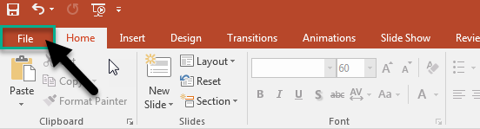

In File, Click New.

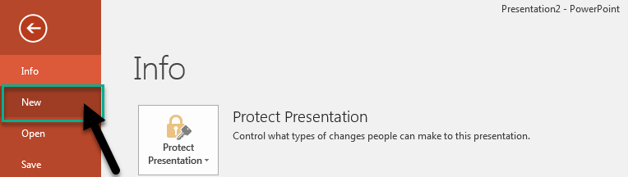

2. Find the Search for Online templates and themes text field.

In the Search for Online templates and themes text field, type accessibility template and press Enter.

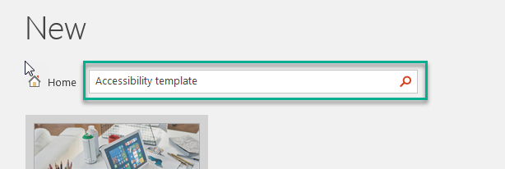

3. In the search results, select the Making Templates Accessible template.

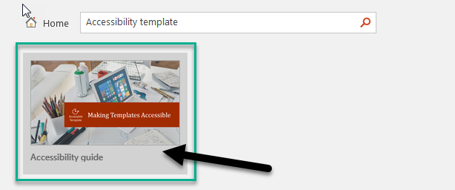

The template preview window will appear.

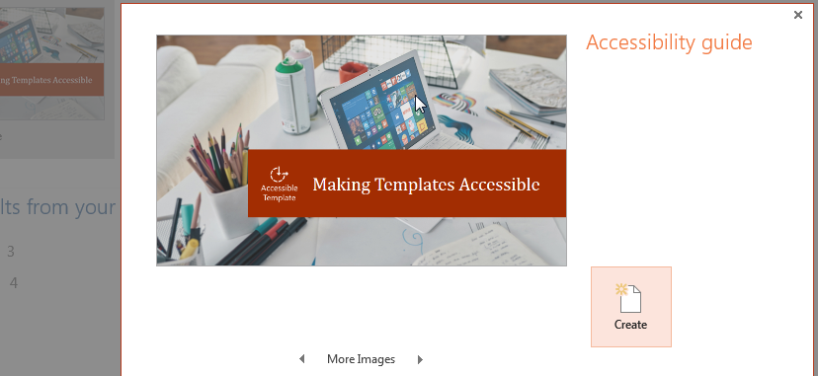

4. In the template preview window, select Create.

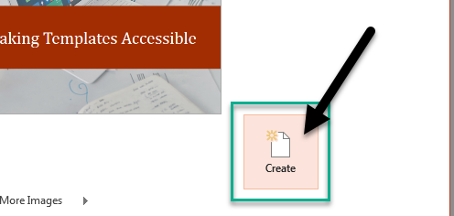

5. You will now be able to create an accessible PowerPoint presentation using the template that Microsoft has provided.

Search Accessible Designs in PowerPoint 365:
https://support.office.com/en-us/article/make-your-powerpoint-presentations-accessible-6f7772b2-2f33-4bd2-8ca7-dae3b2b3ef25

Use a Built-In Slide Design for Inclusive Reading Order:
- PowerPoint has built-in slide designs that contain placeholders for text, videos, pictures, and more. They also contain all the formatting, such as theme colors, fonts, and effects.
- To make sure that your slides are accessible, the built-in layouts are designed so that the reading order is the same for people who see and people who use technology such as screen readers.

1. On the View tab in the Ribbons tab, click Normal.
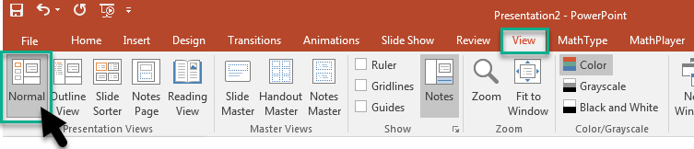

2. In the Thumbnail pane, locate the place where you want to add the new slide.
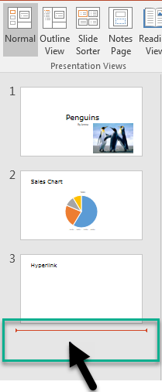

Right-click, and select New Slide. Click the new slide to select it.

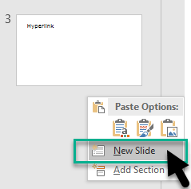

3. On the Design tab in the Ribbons tab, expand the Themes gallery, and select the slide layout that you want.

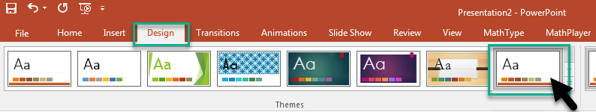

PowerPoint automatically applies this layout to the new slide.

4. Go to the new slide, and add the title and content that you want.

Use Unique Slide Titles:

1. To restore all placeholders for the selected slide, on the Home tab, in the Slides group, select Reset.

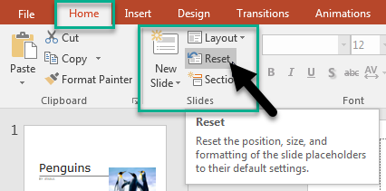

2. On the slide, type a unique and descriptive title.

Hide a Slide Title:
Make a title invisible on the slide, but still voiced by screen readers.
1. On the Home tab, in the Drawing group, select Arrange.
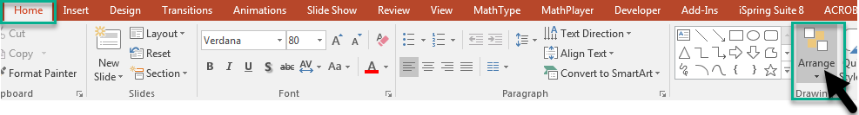
2. In the Arrange menu, select Selection Pane.

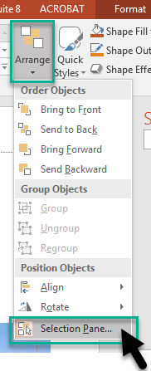
The Selection pane opens on the right side of the slide.

3. In the Selection pane, locate the Title text box, and then click the eye icon next to it.

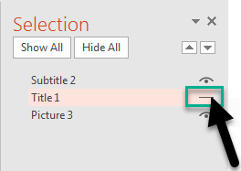

4. The title will be hidden on the slide but readable with a screen reader.

Set the Reading Order of Slide Contents:
- Use the Selection pane to set the order in which the screen readers read the slide contents. The Selection pane lists the objects on the slide in reverse order. When the screen reader reads this slide, it reads the objects in the reverse order listed in the Selection pane.

1. On the Home tab, in the Drawing group, select Arrange.

2. In the Arrange menu, select Selection Pane.
3. In the Selection pane, to change the reading order, do one of the following:
- Drag and drop items to the new location.
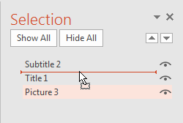
- Select the item and then select the Up arrow button (Bring Forward) or Down arrow button (Send Backward).
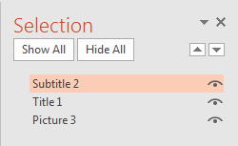

Use Table Headers:

1. Position the cursor anywhere in a table.

2. Select the Design tab.
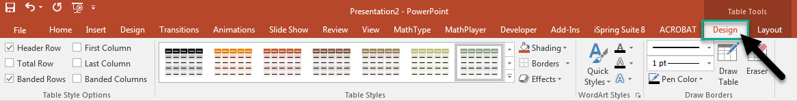
3. In the Table Style Options, select the Header Row check box.
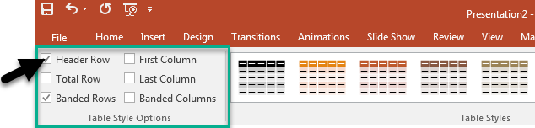
4. In the table, type the column headings.

