How To Use the Accessibility Checker in Microsoft Word
This document will show you how to use the Accessibility Checker in Microsoft Word in order to create an accessible, navigable document.

Please do not hesitate to contact Jen at the Teaching Learning Center at
303.352.3002 or Jennifer.Maxwell@ccd.edu

How to Check Accessibility with the Accessibility Checker:

1. Select File in the Ribbons tab.

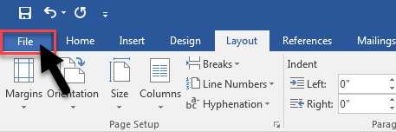

2. In File, select Info.

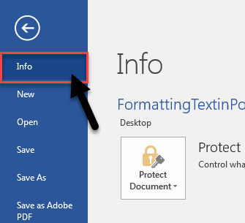

3. In Info, find the ‘Inspect Document’ section.
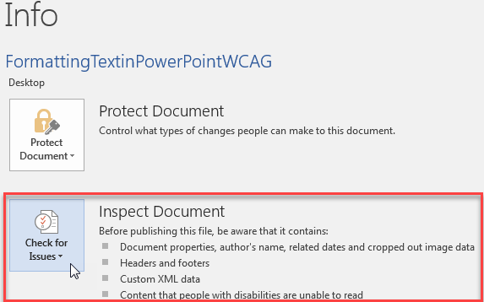

4. Select Check for Issues.

5. The dropdown menu will appear. Select Check Accessibility.
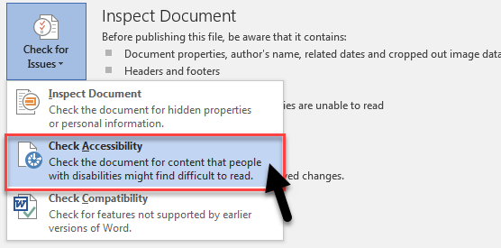

6. The Accessibility Checker will run an inspection of your document.

7. The results will appear on the right side of the document.
The Accessibility Checker will give you a list of errors to correct.

