How to Set Auto-Formatting Options in Microsoft Word
This document will show you how to change some auto-formatting settings in Microsoft Word in order to create an accessible, navigable document.

Please do not hesitate to contact Jen at the Teaching Learning Center at
303.352.3002 or Jennifer.Maxwell@ccd.edu

To change some auto-formatting settings:
- This aids screen reader accessibility of lists.

1. Click on the File tab in the ribbon.

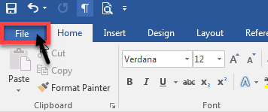

2. Select Options from the bottom of the left navigation list.

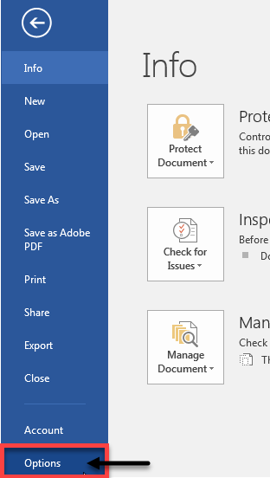
The Word Options dialog box will appear on the screen.

3. Select Proofing from the Word Options menu.

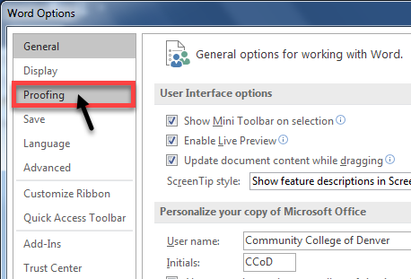

4. Select AutoCorrect Options from the Proofing dialog box.

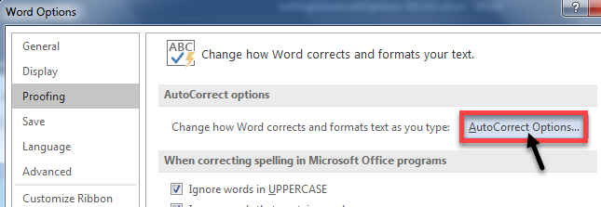

5. Select the AutoFormat As You Type tab from the AutoCorrect dialog box.

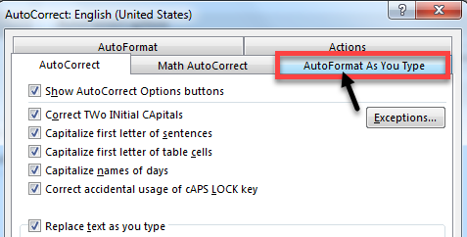

6. Uncheck Automatic numbered lists (1) and Format beginning of list item like the one before it (2). Click OK (3) to save changes and exit the AutoCorrect dialog box.

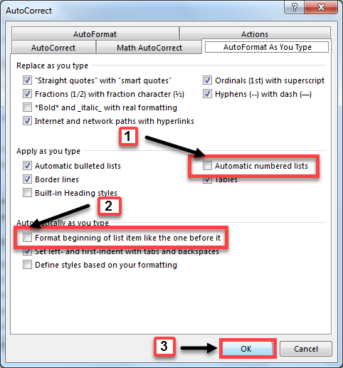

7. Click OK on the next screen to save changes and exit the Word Options dialog box to return to the document.

