How to Create Accessible Lists in Microsoft Word
This document will show you how to create lists in Microsoft Word in order to create an accessible, navigable document.

Please do not hesitate to contact Jen at the Teaching Learning Center at
303.352.3002 or Jennifer.Maxwell@ccd.edu

To create an unordered list:
1. Find the Paragraph command group in the Home ribbon.

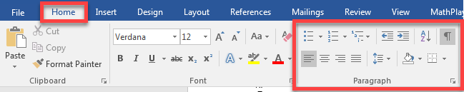

2. Click on the arrow next to the bulleted list to show the bullet library.

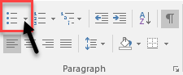

3. Select the default closed bullet symbol by clicking on it.

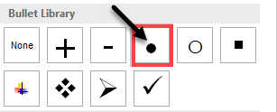

- For accessibility, the closed bullet symbol will be read as “bullet” before the text to indicate that it is a list entry. Other symbols will not be read correctly.

To create ordered lists:
1. Find the Paragraph command group in the Home tab.

2. Ordered lists are sequential and can be numbered as either single-level (1) or multi-level (2).

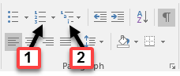

3. Click on the arrow next to the numbering list to show the single-level numbering library.

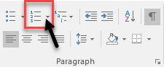

4. Select a single-level numbering scheme by clicking on it.

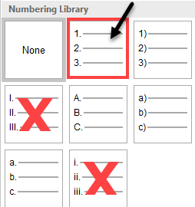

- Roman numerals should be avoided as these are not read correctly by the screen reader.

5. Click on the arrow next to the multi-level list to show the multi-level list library.

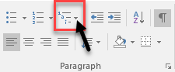

6. Select a multi-level numbering scheme by clicking on it.

