How to Create Accessible Tables in Microsoft Word
This document will show you how to construct tables in Microsoft Word in order to create an accessible, navigable document.

Please do not hesitate to contact Jen at the Teaching Learning Center at
303.352.3002 or Jennifer.Maxwell@ccd.edu

To create a simple, accessible table:
- Simple tables that contain a uniform grid of column cells and row cells are generally accessible for a screen reader.

1. Click on the Insert tab in the ribbon.

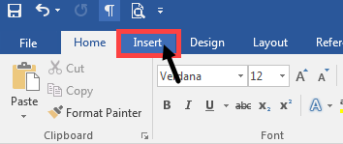

2. Click on the small arrow under the Table icon to show the Insert Table options.

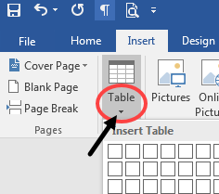

3. There are 2 ways to create a table: (1) dragging through the grid or (2) clicking on Insert Table.

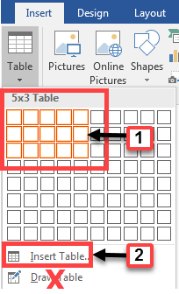
- Do not create a table using Draw Table, because it will not accessible with a screen reader.

3a. Drag through the grid to set the number of rows and columns. Release the mouse button and a blank table will appear in Word.

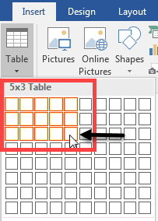

3b. Click Insert Table (1), which will open the Insert Table dialog box (2). Under Table size (3), select the number of desired columns and rows. Click OK (4) and a blank table will appear in Word.

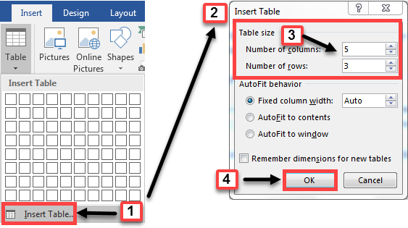

4. After using either table creation method, a new Table Tools tab and ribbon will appear with additional formatting options in 2 sub-tabs: Design and Layout.

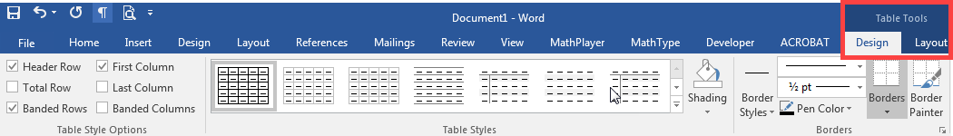

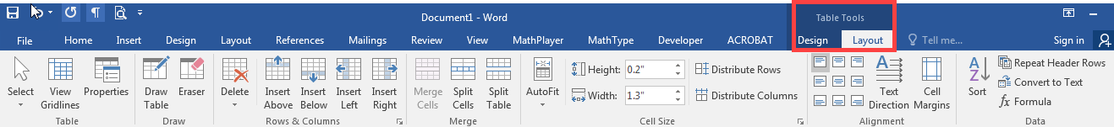

5. From the Layout tab of Table Tools, click on the Properties button. The Table Properties dialog box will appear on the screen. This can also accessed by right-clicking in the upper left corner of the table.

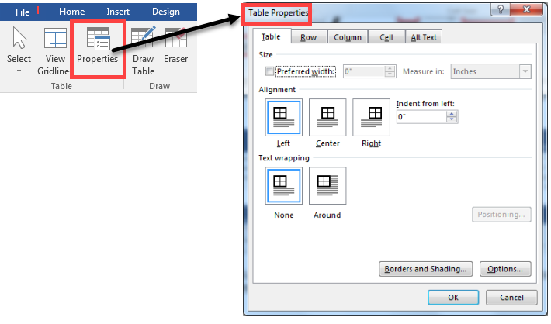

6. Select the Row tab. Check the Repeat as header row at the top of each page.

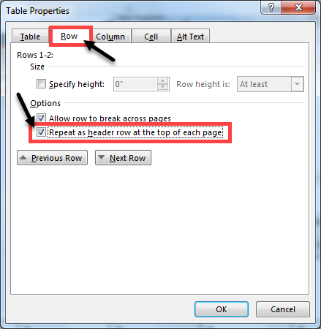

7. Select the Alt Text tab (1). Add a short description in the Title box (2). Add a longer explanation in the Description box (3). Click OK to save changes and exit (4).

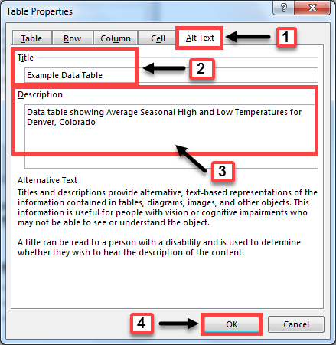

- A screen reader will read the Description, if present, or the Title if there is no description.

Example Data Table:
Average Seasonal High and Low Temperatures, Denver, Colorado
 | Spring | Summer | Fall | Winter
Average High | 69 | 88 | 72 | 51
Average Low | 45 | 67 | 52 | 33

Accessible Alternatives for Complex Tables
- Complex tables often include merged or split cells that disrupt the uniform grid organization. These are not accessible, because the screen reader cannot discern the relationships within the non-uniform cell structure.

1. Example of merged cells: The original table structure consisted of 6 rows and 7 columns. It now contains 6 different merged cells.

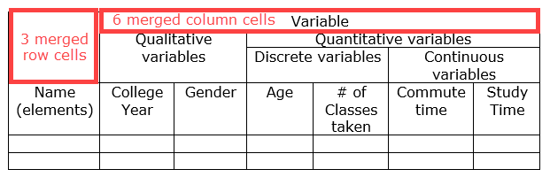

2. Example of split cells:

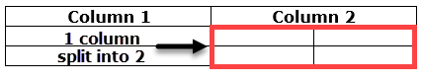

3. Create an alternative multi-level list using headings:

Variables

Qualitative variables

College year

Gender

Quantitative variables

Discrete variables

Age

# of classes taken

Continuous variables

Commute time

Study time

4. Split complex tables into smaller, simple tables

Table 1: Qualitative Variables
Name | College year | Gender

Table 2: Quantitative Discrete Variables
Name | Age | #Classes taken

Table 3: Quantitative Continuous Variables
Name | Commute time | Study time

